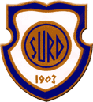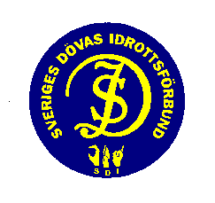

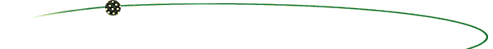
INTERNATIONAL DEAF FUTSAL TOURNAMENT

IK Surd 110th anniversary, Gothenburg in Sweden

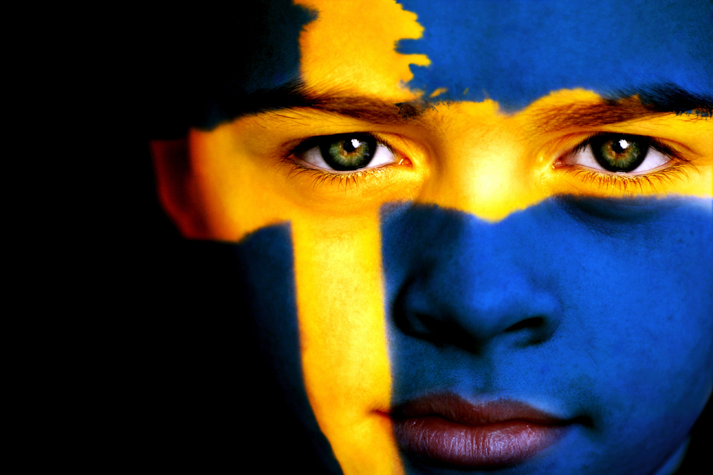

MEN – WOMEN – VETERANS
5 VS 5
30-31/03/2013
INTERNATIONAL PARTY
31/03/2013

Address to Futsal Address to International Party
Lindholmens Sporthallar Dalheimers Hus
Anders Carlssons Gata 10 Slottsskogsgatan 12
Gothenburg Gothenburg

Form for registration for

INTERNATIONAL FUTSAL TOURNAMENT
IK Surd 110th anniversary

by letter or e-mail Idrottsklubben Surd
Järntorget 8
41304 Gothenburg
SWEDEN
e-mail: nanette.slattman@sdrf.se
www.iksurd.se/110years

Name of Deaf Sport Club:

_____________________________________________________________

Address:

____________________________________________________________

_____________________________________________________________

Country:

______________________________________________________________

E-mail:

____________________________________________________________

We would like to participate in the International Futsal Tournament from IK Surd
at 30-31 March 2013 with:

….…. Men team (5 players + substitutes)

….…. Women team (5 players + substitutes)

….…. Veteran +35 team (5 players + substitutes)

Signature:

___________________________________________________

Winner- Premium

1. Place 2.Place 3.Place

To 10 participating teams 400 Euro 200 Euro 100 Euro
To 20 participating teams 800 Euro 400 Euro 200 Euro

The registration fee is 200 Euro/team

Preliminary entry: 30.12.2012
Payment: 30.01.2013

Bank account: IK Surd
Bank: Nordea
BIC: NDEASESS
IBAN: SE70 9500 0099 6042 0527 0889
Purpose: Futsal 110years, Association (name of team)

After this tournament is finished there will be an international party on Saturday evening. Check our website www.iksurd.se/110years
or Facebook IK Surd 110 years. There is video on youtube.

Accomodation:
In Gothenburg, there are lots of hotels and hostels, which you can find online. If you require advice, please contact Nanette Slattman.
e-mail: nanette.slattman@sdrf.se

We are looking forward to meet new friends and sports fans from nearby and far.
Welcome to the heart of Scandinavia!

Yours sincerely

The Sport Club IK Surd

