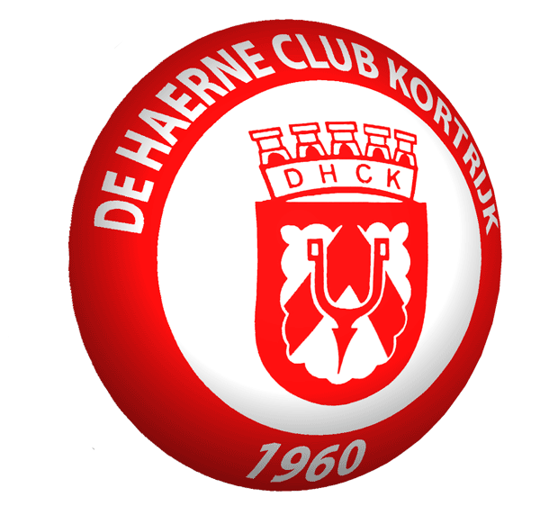

Dear sportfriends,

DHC Sport Kortrijk would like to invite you for celebrating the 50th anniversary of our football club.

The tournament will take place in Easter weekend : Saturday and Sunday 30-31 march 2013.
We would like to offer every club a warm welcome. We hope you are interested in what we have to offer.

INTERNATIONAL 5-A-SIDE INDOOR FUTSAL TOURNAMENT FOR WOMEN
The contest will consist of six lady teams, each containing five players (one keeper and four players). These games will be played indoor.

INTERNATIONAL 11-A-SIDE FOOTBALL TOURNAMENT FOR MEN
This contest will consist of six teams. Each team has eleven players (one keeper and ten players). These matches will be played outdoors.

We aim to get at least five teams from different countries (men & women).

SPORTS CENTRE “DE WEIMEERSEN”
The futsal and outdoor football will take place in:
Sportcentrum “De Weimeersen”.
Rollegemkerkstraat
8510 Rollegem

The sports centre consists of a bar and several beverages & food will be available throughout the championship.

HOTEL
You will retrieve a list of all available hotels on http://www.kortrijk.be/vrije-tijd/toerisme/slapen-eten-en-drinken/slapen or on www.booking.com (search for Kortrijk hotels).

REGISTER
Your club wants to join our tournament? Register your team before 31 January 2013 and pay the fee of 200 EUR on IBAN-number : BE09 0682 4340 5157 and BIC-code : GKCCBEBB.
When you are present at the tournament, you will be reimbursed for 100 € back.

If you still have questions, don’t hesitate to ask me, you can contact me on 50yearsdhckortrijksport@gmail.com.

We hope to wellcome you all on our tournament.

Chair of tournament DHC Sport Kortrijk
Vandenbroucke Nick

